Assignment 3 Performance Report
CS6025 Parallel Processing
Jordan Bourque (3481123)
April 7, 2026
Part A) Design Summary:
Description of adaptive integration method: *Unchanged from A2*
The integration is done using Adaptive Simpson’s Rule. The idea is to approximate the integral over an interval using Simpson’s formula, then compare that result to splitting the interval in half and applying Simpson’s rule to each half. If the difference between these two results is within the tolerance, the interval is accepted. If not, the interval is split again and the process continues recursively. This creates smaller intervals only where needed, which makes the method more efficient than using a fixed grid.
MPI dynamic design: *Mode 2 from A2 became Mode 1 for A3, otherwise unchanged*
The dynamic MPI design incorporates a queue for Rank 0 to manage all worker processes. Work is divided into intervals and distributed to workers on demand. When a worker completes its task, it sends the result back to the master and requests more work. If additional work exists, the master assigns another interval; otherwise, the worker is stopped. This approach allows work to be redistributed dynamically, improving load balancing for irregular workloads.
Hybrid design:
The hybrid design was based off the static scheduling approach from Assignment 2. This design statically splits the total interval [0,1] into K coarse intervals and distributes them across worker processes. Each worker processes its assigned intervals locally without further communication, which removes the overhead of dynamic scheduling.
OpenMP strategy:
The portion of the code that could be parallelized was the loop that processes each assigned interval. OpenMP was applied using #pragma omp parallel for reduction(+:sum, tempAcceptedIntervals) to allow multiple threads to compute intervals concurrently. The reduction clause ensures that the final values of sum and tempAcceptedIntervals are combined correctly across all threads. This allows each worker process to further parallelize its computation.

Part B) Results Tables:
Mode 0: 

Mode 1: 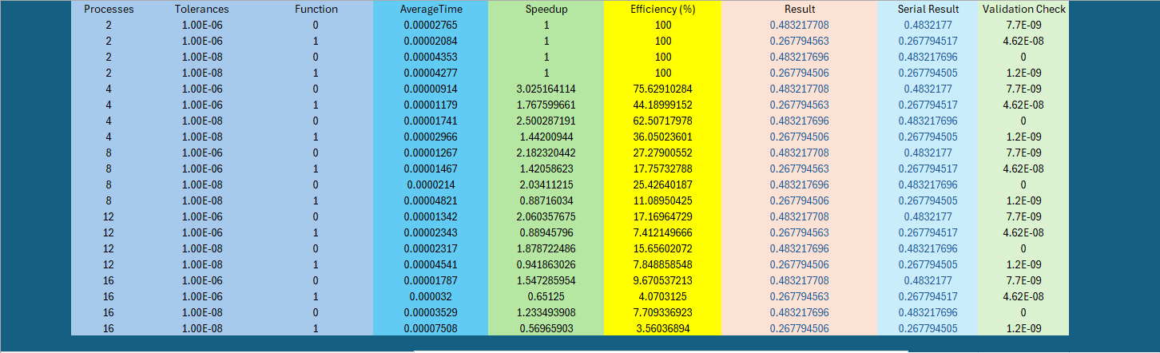

Mode 2: 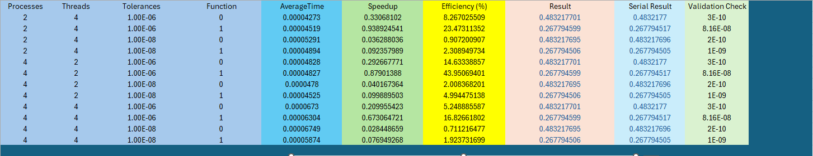

Part C) Plots
Mode 1 Graphs:

Mode 2 Graphs:

Part D) Discussion:

- Why does MPI dynamic perform well for adaptive workloads?
Answer: MPI dynamic performs well for adaptive workloads by reducing waiting times for processes with low workloads to receive new workloads. This allows the master to assign work as needed, rather than distributing all work upfront. Since adaptive integration creates uneven workloads, dynamic scheduling helps keep all processes busy and improves overall efficiency.

- Why might hybrid perform worse?
Answer: Hybrid can perform worse because it removes dynamic load balancing. Work is statically assigned at the beginning, so if some processes receive more difficult intervals than others, they take longer while other processes remain idle. Although OpenMP introduces local parallelism, it cannot fully compensate for this imbalance. Additionally, thread management overhead can further reduce performance, especially for smaller workloads.

- Does OpenMP compensate for lack of MPI load balancing?
Answer: OpenMP partially compensates for the lack of MPI load balancing by allowing each process to parallelize its local work. This can improve performance when there is enough work within each process. However, it does not seem to fully solve the imbalance problem, since work is still unevenly distributed across processes. As a result, some processes might be finishing earlier and remaining idle while others continue working.

- When does hybrid outperform MPI?
Answer: Hybrid can outperform MPI when the workload is relatively balanced and large enough to benefit from local parallelism. In these cases, reducing MPI communication and using OpenMP threads within each process can lead to better performance. However, for highly irregular workloads, MPI dynamic scheduling tends to perform better due to its ability to redistribute work.

- What is the impact of thread count and process count?
Answer: It is difficult to fully generalize the impact of thread count versus process count with limited data points, but some trends can be observed. Increasing the number of processes tends to improve load distribution and can increase efficiency, while increasing thread count introduces overhead and may reduce efficiency for smaller workloads. In terms of speedup, Mode 2 shows limited improvement compared to Mode 0, but this may improve with larger workloads or different process/thread configurations.

Experimentation Environment:
